Circles Food Project – Due Friday, February 14, 2020

Level 1: Vocabulary
- Identify the 12 circle vocabulary words/parts
- Create a circle food item that displays all 12 parts
- Food item can consist of 1 large circle or small circles
- You can use more circle terms if desired
- Provide a blueprint of your project clearly defining the vocabulary used on your project

Grading:
7 pts X 12 vocabulary words = 84 pts
10 pts for accuracy of each word
6 pts for creativity and neatness
Total: 100 pts

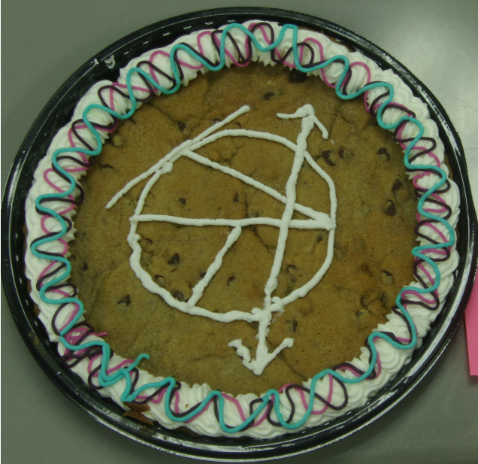
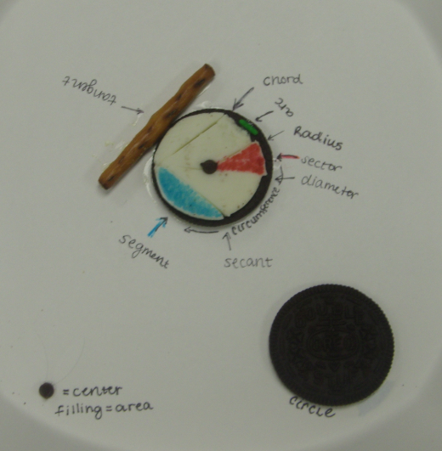

She brought in Oreos to share.

